PROJECT REPORT

Weather to wardrobe adviser
(https://github.com/tanisha25bce10578/Weather-to-Wardrobe-Advisor.git)
Fundamentals in ai and ml (CSA2001)

BY TANISHA(25BCE10578)

FACULTY: PRAKASH NB



INTRODUCTION:
The Weather-to-Wardrobe Advisor is a Python program that helps you decide what to wear every day. This system uses a Learning Loop, which is different from static weather apps. It takes into things like temperature, humidity, and wind to figure out how comfortable a user is and changes its suggestions based on its past feedback.

PROBLEM STATEMENT:-
Raw temperature readings sometimes fail to account for the Humidity or the Wind Chill effect. Moreover, comfortable clothing is also a matter of personal taste. A static if-else system cannot adapt to a person’s specific tolerance for cold or heat.

REQUIREMENTS:-
Functional:
Requirement ID | Feature | Description
Input | Data Entry | Inputs the Temp, Humidity, and Wind from user.
Process | k-NN Logic | Find 3 closest matches in history using math function.
Storage | JSON Logging | Save and load data to keep the "memory" alive.
Feedback | Model Training | Change the database when the user corrects a suggestion.

NON-FUNCTIONAL:
Category | Requirement | Goal
Performance | Speed | Fast recommendations.
Reliability | Recovery | Auto-generate data file if that is deleted.
Usability | UX | Clear prompts and bold recommendations.
Portability | OS Support | Runs when Python is installed.

SYSTEM ARCHITECTURE:-
1.) Input Module: Inputs Temperature, Humidity, and Wind Speed from the user.
2.) Processing Module: Loads data from commute_log.json.
- It calculates by Euclidean distances formula for all historical points.
- It sorts and matches the top 3 neighbours.
3.) Feedback Module: If the user rejects a suggestion, the code captures the Correct Outfit and changes it to the JSON database for future training.

Design Decisions & Rationale:-
Algorithm (k-NN): We chose k-Nearest Neighbors because clothing choice is the person’s choice. Instead of hard rules, the system finds the 3 most similar type days in history to make a recommendation.
Data Normalization (Feels Like): A custom formula adjusts temperature for humidity (above 26°C). This ensures the python code to compare how the weather actually felt rather than just the thermometer reading.
Storage Choice (JSON): I opted for a JSON file instead of a SQL database. It is lightweight, requires no early setups and is easily readable by both humans and the computer.

IMPLEMENTATION DETAILS:-
Category | Component | Details
Core Algorithm | k-Nearest Neighbors | Finds the 3 most similar weather patterns in history.
Normalization | Heat Index | Adjusts Temp based on Humidity for "Feels Like" accuracy.
Learning | Feedback Loop | System changes the user corrections to the database for improved future use.
Tech Stack | Python 3.x | Libraries: math, json, statistics, os.
Input Fields | Weather Data | Morning Temp (°C), Humidity (%), Wind Speed (km/h).

RESULTS:-
1.) Real-time Processing: The calculation of Euclidean distance and neighbour sorting occurs near-instantaneously, ensuring a smooth user experience.
2.) Algorithmic Accuracy: The system successfully implements the k-Nearest Neighbours logic, identifying the most logic historical weather patterns to provide a personalized recommendation for the user.
3.) Data Persistence: The JSON storage mechanism proved robust, successfully reloading historical data upon every restart without any data loss.
4.) Effective Normalization: The Feels Like pre-processing correctly identifies humid days, allowing the AI to check the difference between a dry 30°C and a humid 30°C.

Screenshot of output attached :
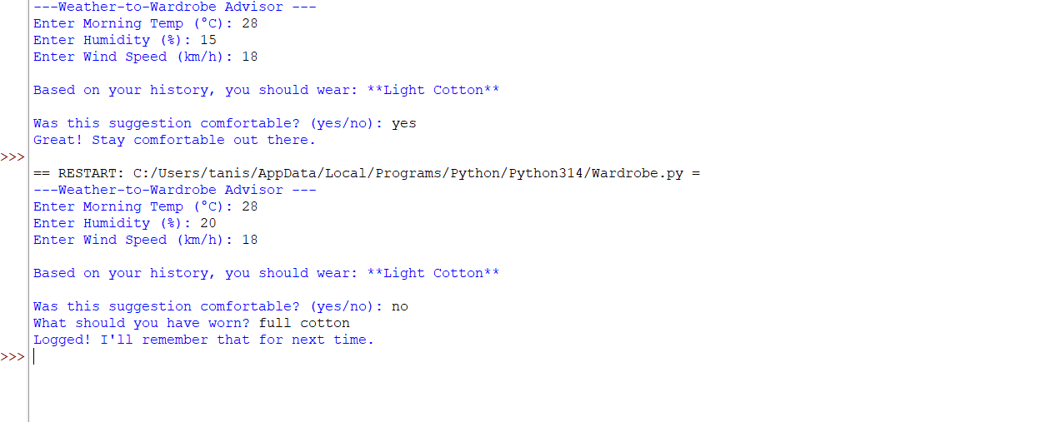

LEARNINGS & KEY TAKEAWAYS:-
1.) Subjectivity in Data: One of the most important thing I learned was that comfort is different for everyone. It is often wrong to hard-code rules like "if it's 15°C, wear a jacket." This project showed how Machine Learning can model personal preferences when traditional logic doesn't work.
2.) The Power of Data Normalization: We learned that raw data can be wrong. It could be 30°C on the thermometer, but with 90% humidity, it feels much hotter. Using the Feels Like formula taught us how Feature Engineering, or pre-processing features, can make an algorithm much more accurate.
3.) The importance of data persistence: When designing the JSON logging system, it was clear that an AI's memory is what makes it smart. A basic skill for making any app that grows with the user is knowing how to read, write, and update a local database file.
4.) The Feedback Loop: We learned the value of Supervised Learning. By including a "Was this comfortable?" prompt, we transformed the user into a trainer. This taught us how human in the loop systems can self-correct and improve their own datasets over time.

Repository Link:-
https://github.com/tanisha25bce10578/Weather-to-Wardrobe-Advisor.git

